1)Problem Description:
Develop a Python program that safely calculates the square root of a number provided by the user. Handle exceptions for negative inputs and non-numeric inputs.
Input Format:
User inputs a number.
Output Format:
Print the square root of the number or an error message if an exception occurs.

PROGRAM:
import math
try:
a=float(input())
if a>=0:
b=a**0.5
c="%.2f"%b
print("The square root of",float(a),"is",c)
else:
print("Error: Cannot calculate the square root of a negative number.")
except EOFError:
print("Error: could not convert string to float")
except ValueError:
print("Error: could not convert string to float")

OUTPUT:
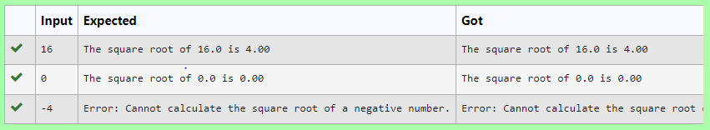

2) Write a Python program that performs division and modulo operations on two numbers provided by the user. Handle division by zero and non-numeric inputs.
Input Format:
Two lines of input, each containing a number.
Output Format:
Print the result of division and modulo operation, or an error message if an exception occurs.

PROGRAM:
try:
a=input()
b=input()
c=int(a)/int(b)
d=int(a)%int(b)
except ZeroDivisionError:
print("Error: Cannot divide or modulo by zero.")
except:
print("Error: Non-numeric input provided.")
else:
print("Division result:",c)
print("Modulo result:",d)

OUTPUT:
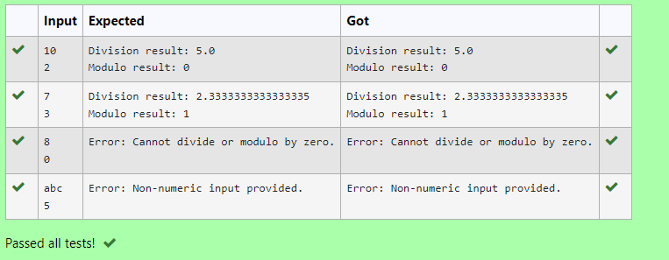

3) Develop a Python program that safely performs division between two numbers provided by the user. Handle exceptions like division by zero and non-numeric inputs.
Input Format: Two lines of input, each containing a number.
Output Format: Print the result of the division or an error message if an exception occurs.

PROGRAM:
try:
a=input()
b=input()
c=float(a)/float(b)
except ZeroDivisionError:
print("Error: Cannot divide or modulo by zero.")
except:
print("Error: Non-numeric input provided.")
else:
print(c)

OUTPUT:
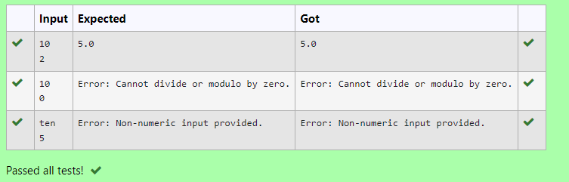

4) Write a Python script that asks the user to enter a number within a specified range (e.g., 1 to 100). Handle exceptions for invalid inputs and out-of-range numbers.
Input Format:
User inputs a number.
Output Format:
Confirm the input or print an error message if it's invalid or out of range.

PROGRAM:

try:
n=input()
if(int(n)>0 and int(n)<101):
print("Valid input.")
else:
print("Error: Number out of allowed range")
except:
print("Error: invalid literal for int()")

OUTPUT:
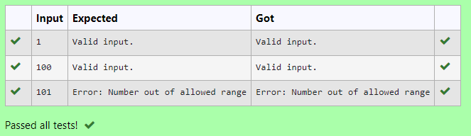

5) Write a Python program that asks the user for their age and prints a message based on the age. Ensure that the program handles cases where the input is not a valid integer.
Input Format: A single line input representing the user's age.
Output Format: Print a message based on the age or an error if the input is invalid.

PROGRAM:

try:
a=input()
if int(a)>=0:
print("You are",a,"years old.")
else:
print("Error: Please enter a valid age.")
except:
print("Error: Please enter a valid age.")

OUTPUT:
